- Data Import
- Download northwind-db.sql from classroom
- Open XAMPP and Click Explorer
- Copy downloaded database to mysql folder.
- Open Shell from XAMPP Admin Panel.
- Create database <yourname>northwind and exit
Query:

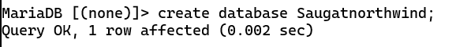

- Import database in <yourname>northwind using following command at SHELL
Query: mysql -u root -p rajeshnorthwind < c:\xampp\mysql\northwind-db.sql

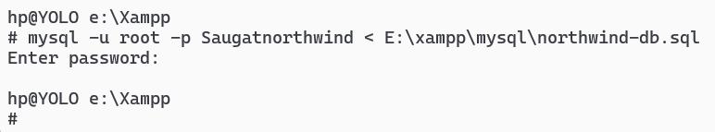

- Connect to database
Query:
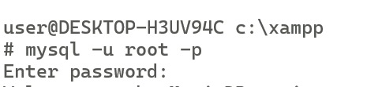

- Use <yourname>northwind database using
i. use northwind:
Query:

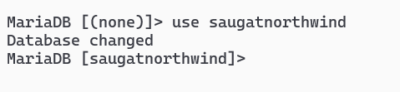

ii. show tables
Query:

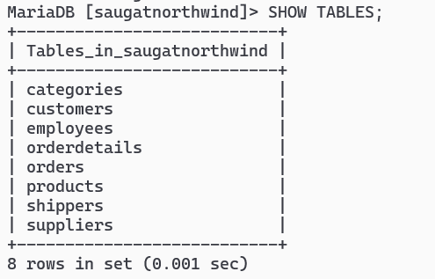

iii. Check attributes and constraints in each tables i.e. DESCRIBE <tablename>
Query:

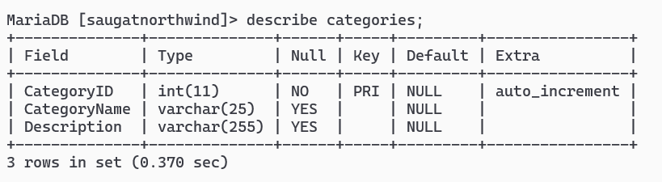
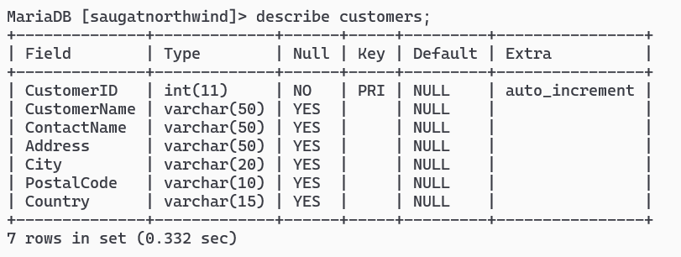
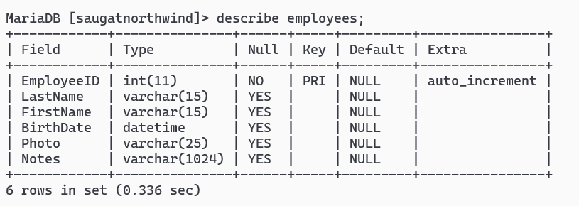
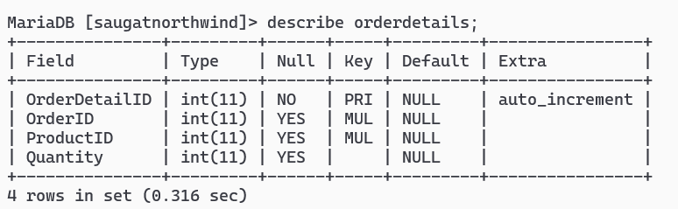
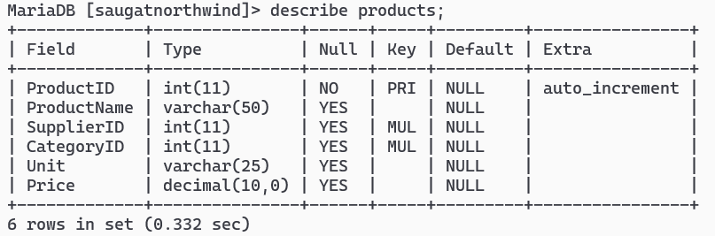
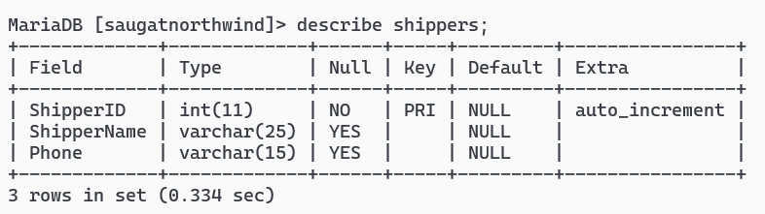
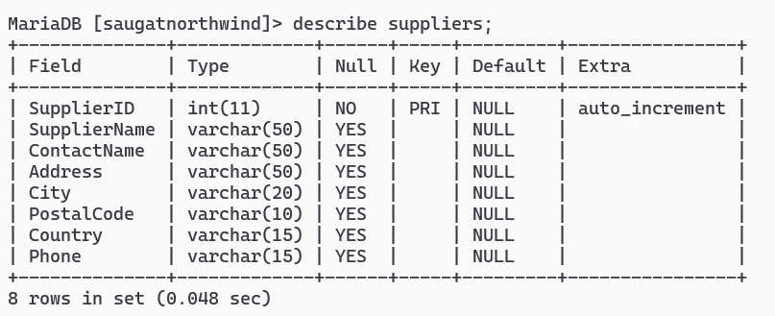

- QUERY Languages (DQL)
- Project CategoryName from categories
Query:

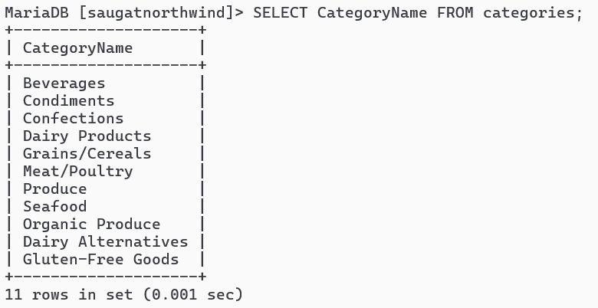

2. Project country from customers
Query:

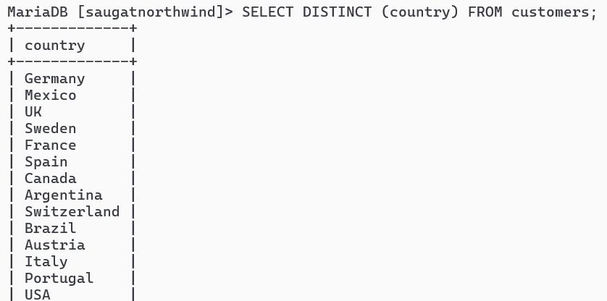
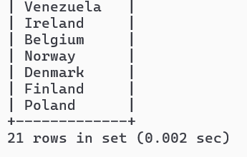
3. Project city, country from customers
Query:

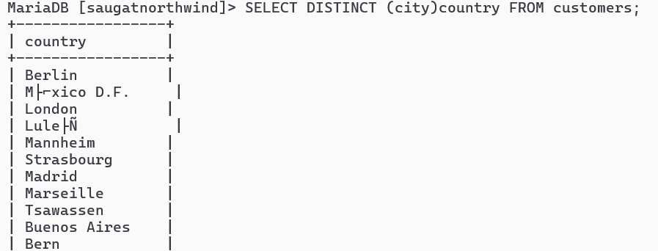
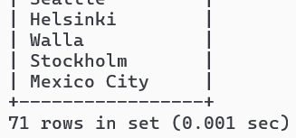

4. SELECT CustomerName from customers who are from Paris City
Query:

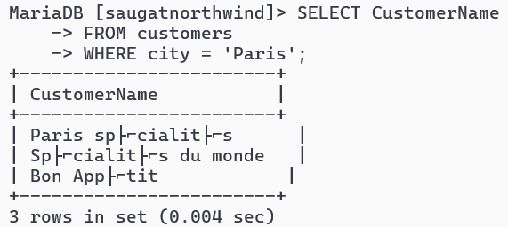

5. SELECT CustomerID from customers who are from Spain
Query:

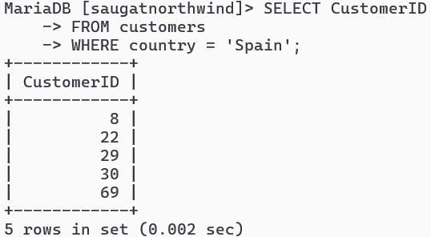
6. SELECT CustomerID, CustomerName from customers who are from Mexico or Italy
Query:

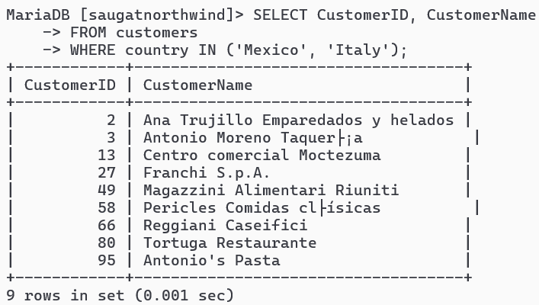
7. SELECT all from customers who are from Frankfurt a.M. and Germany
Query:

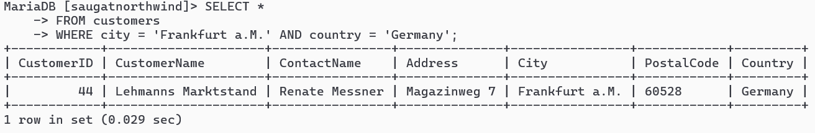

8. SELECT all from customers who are from city having names that start with first letter of Your Name.
Query:

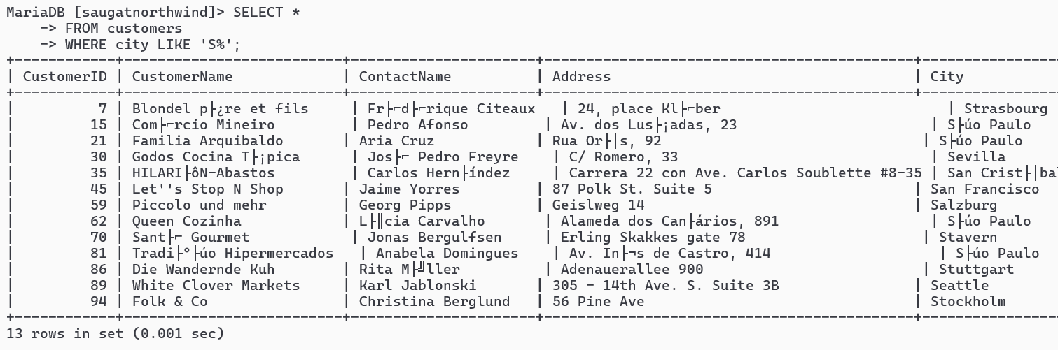

9. SELECT all from customers who are not from Venezuela or Argentina
Query:

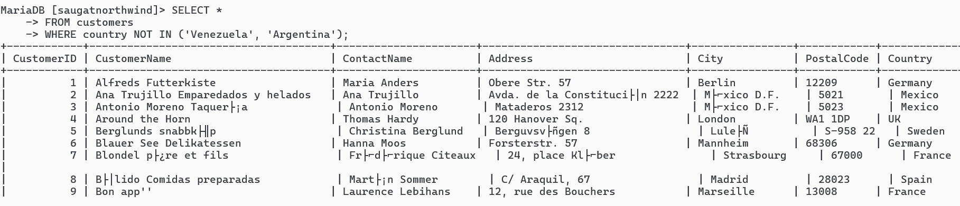
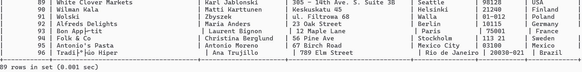
10. SELECT all from customers who are from G7 Countries
Query:

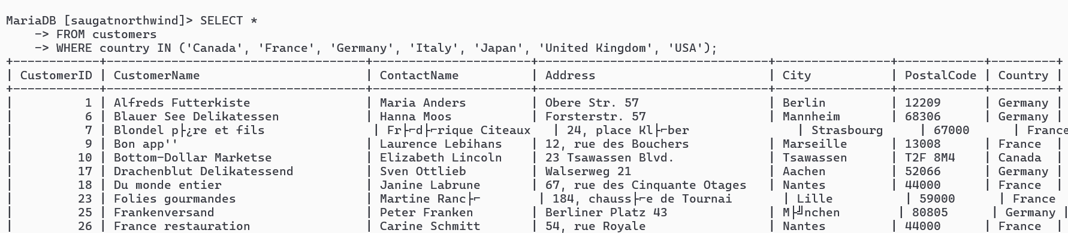

11. SELECT all from customers who have PostalCode containing 50
Query:

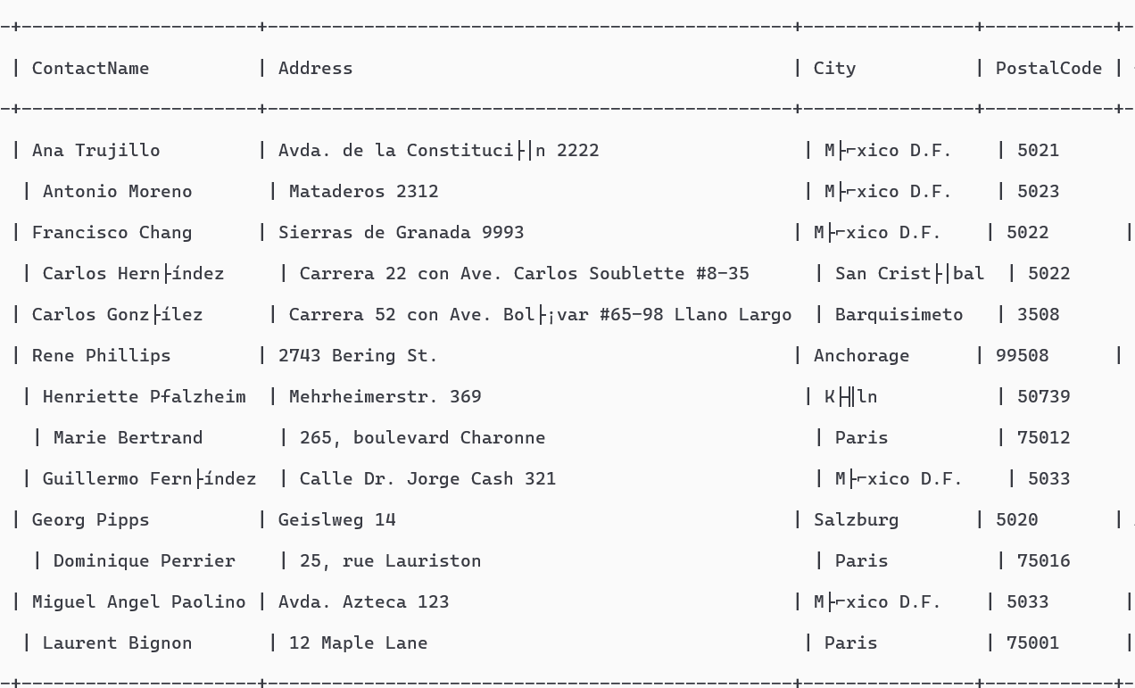
12. SELECT all from customers having PostalCode containing 31 and from Mexico City or Toulouse.
Query:

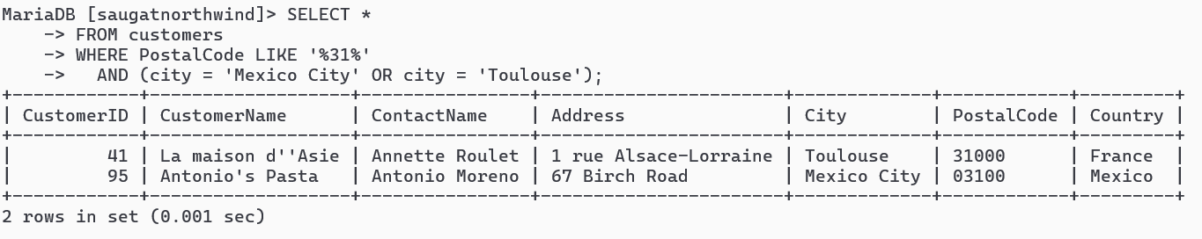
13. SELECT all from customers who are not from Elgin
Query:

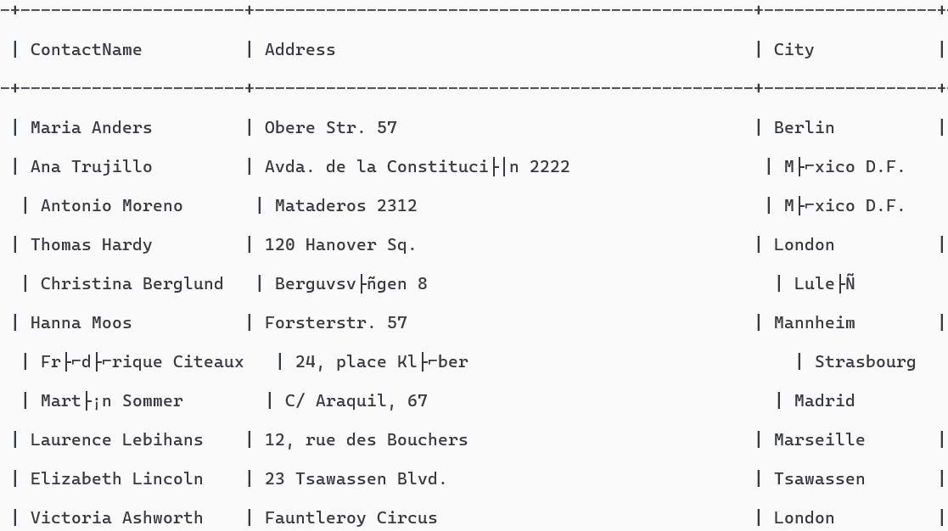
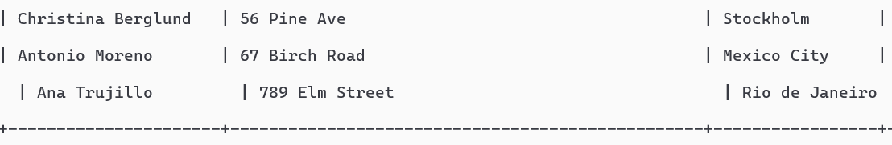
14. SELECT all employees who are born on July
Query:

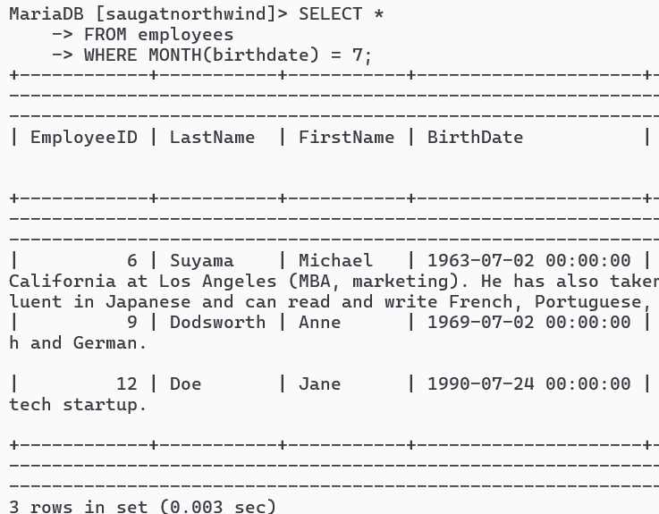

15. SELECT all employees having BA degree in Notes
Query:

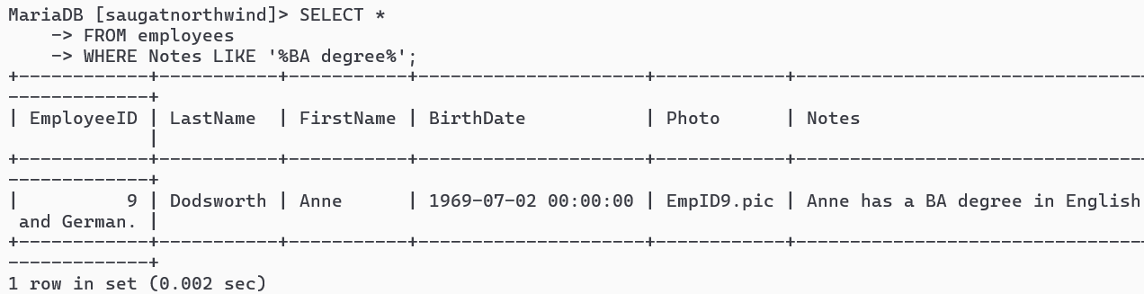
16. SELECT all suppliers from Australia and Sweden
Query:

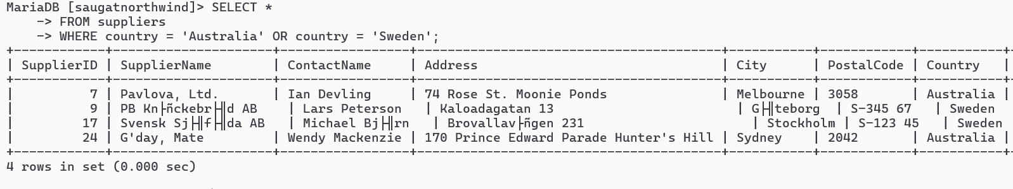

17. Find name and count of suppliers from different countries.
Query:

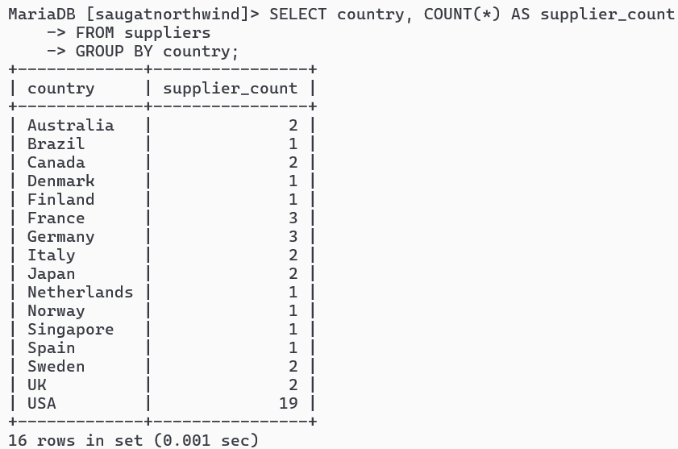
18. Find name and count of customers from different cities.
Query:

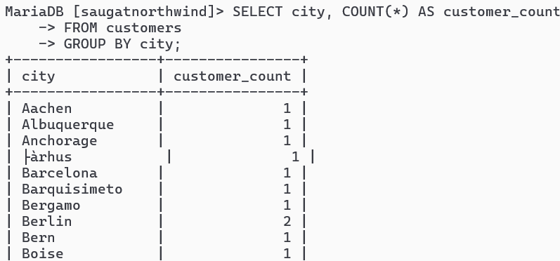
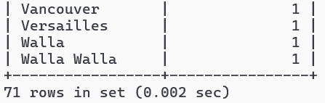
19.Find number of orders made by employee along with employeeID
Query:

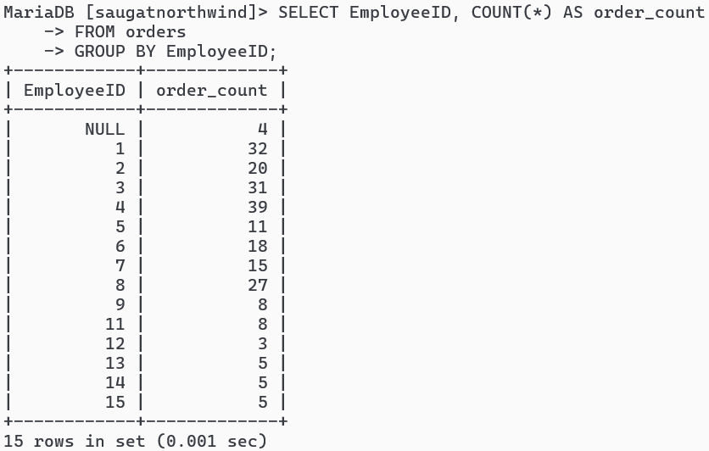

20. Find number of orders made by customers along with customerID
Query:

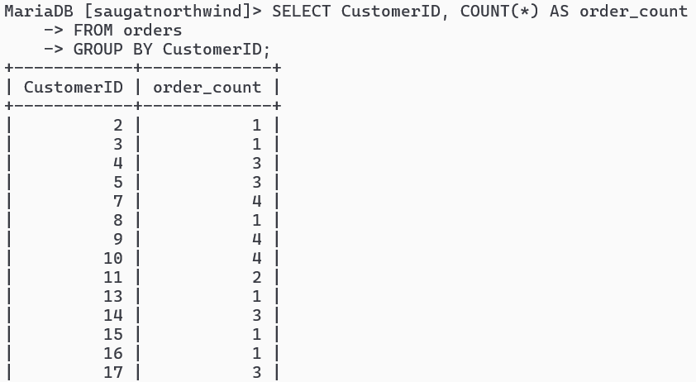
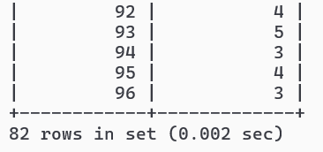
21. Find all order that are shipped by shippers having 2 or 4 shipperID
Query:

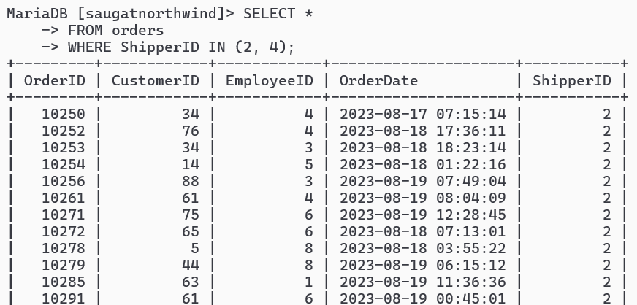
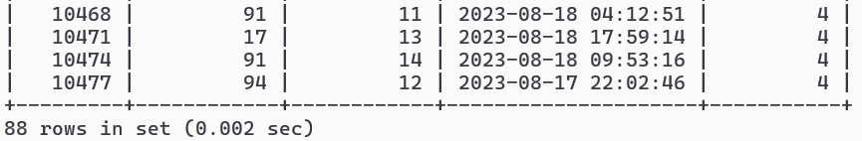

22. SELECT all product having categoriesID 5
Query:

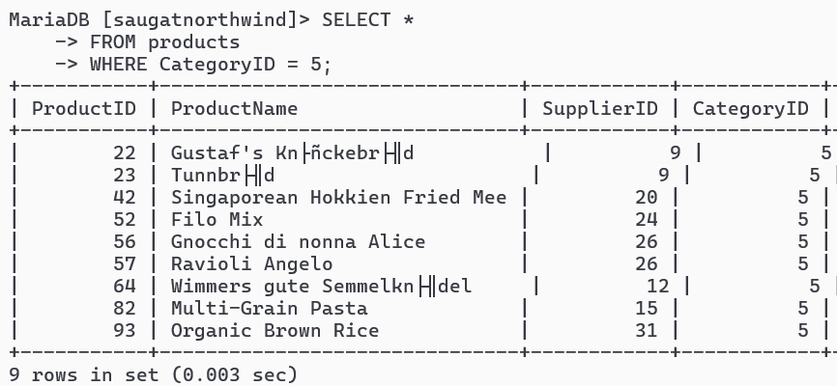
23. SELECT all products having ProductName that starts with First Letter of your name.
Query:

